Homepage

Welcome to our webpage where our goal is to visualize the narrative rhetoric of social pitches.

What is ‘Social Entrepreneurship’?

‘Social Entrepreneurship’ represents a unique blend of economic ingenuity and social responsibility within the entrepreneurial context. It plays a vital role in creating a sustainable modern society by supporting marginalized communities, preserving and amplifying artistic and cultural heritage, and championing environmental conservation (Miller et al., 2012). The significance of social entrepreneurship has increasingly recognized as it transcends traditional market limitations by not only generating economic value but also by fostering social benefits. It catalyzes transformation at individual, institutional, and national levels by adeptly filling the voids conventional markets could not reach out to (Saebi et al., 2019). This innovative paradigm is instrumental in orchestrating comprehensive societal progress.



Why is this visualization important?

The visualization tools featured on our website draw from an annual social pitch competition for university students in South Korea, spanning across 11 years. These tools offer deep insights into the evolving narrative strategies employed by participating teams. They are particularly beneficial for users who:

1) Aim to understand the ebb and tide of pressing societal issues over time,

2) Seek to compare and contrast participant strategies from differing time frames,

3) Or desire to identify and group universities with similar narrative approaches.

 

Reference

Miller, T. L., Grimes, M. G., McMullen, J. S., & Vogus, T. J. (2012). Venturing for others with heart and head: How compassion encourages social entrepreneurship. *Academy of Management Review, 37*, 616-640.

Saebi, T., Foss, N. J., & Linder, S. (2019). Social entrepreneurship research: Past achievements and future promises. *Journal of Management, 45*, 70-95.

Images by Vecteezy, Icons by Flaticon

Tutorial

Welcome to the Tutorial page! We've designed our visualization pages to be intuitive and user-friendly, but just in case you experience trouble, this page has got your back. Here, you'll find all the tips and tricks you need to smoothly navigate through the functions of the website. Feel free to come back whenever you're feeling a bit lost!

There are a total of 5 tools you can use on this website.

Section A explains how you can use the basic interface.

Section B details how to interpret the resulting graph.

How to use **Chronology**

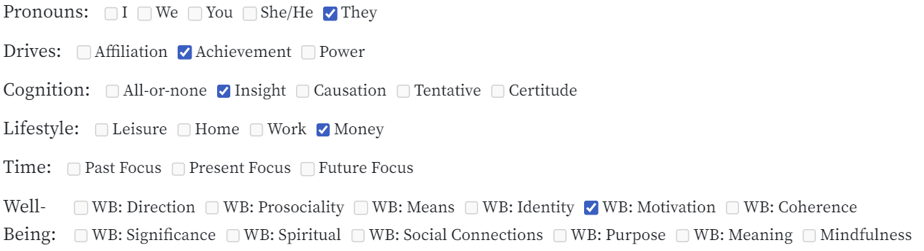

A) On the **Chronology** page, you can choose from 32 checkbox options each representing a certain word category. For simplicity’s sake, you can compare up to a maximum of 5 word categories. After choosing your options, a corresponding graph will appear like the example below.

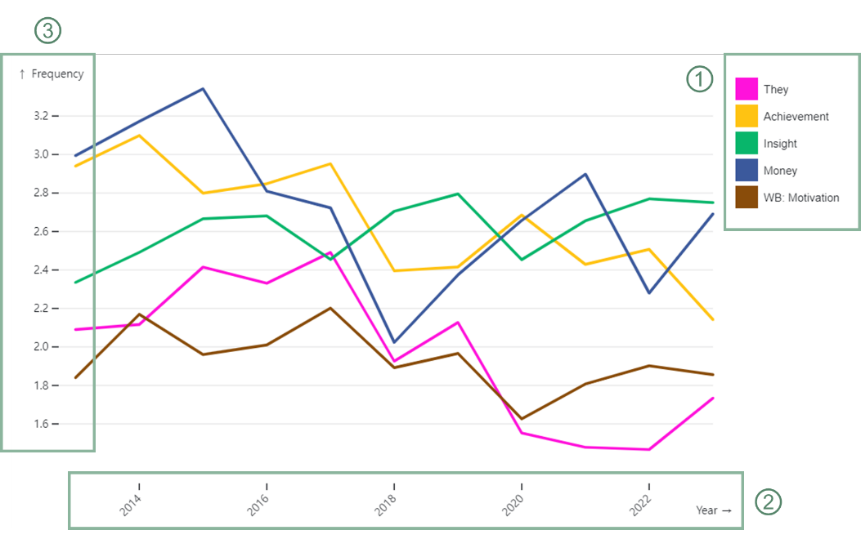

B) ① This legend box shows what color represents each word category.

② The X-axis represents the years from 2013 to 2023.

③ The Y-axis represents the frequency values of the word categories. *Be aware that* it automatically changes depending on the maximum value of the chosen categories.

How to use **Comparison**





A) On the **Comparison** page, you can choose 2 pairs of year-university options from the dropdown menu. *Be aware that* some universities may not appear as options depending on the year selected as not all universities participated every year.

You can also choose from 32 checkbox options each representing a certain word category. For simplicity’s sake, you can compare up to a maximum of 5 word categories. After choosing your options, a corresponding graph will appear like the example below.

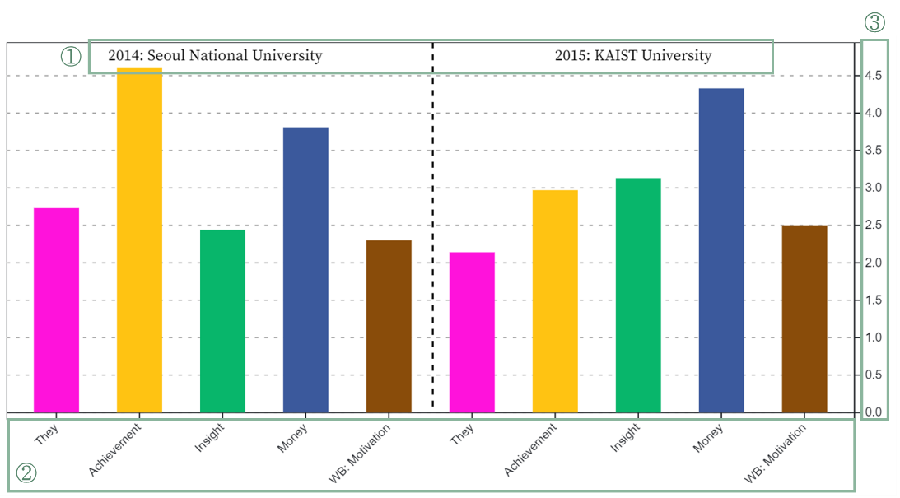

B) ① The left side of the bar graph indicates the values for the first year-university pair.

The right side of the bar graph indicates the values for the second year-university pair.

② The X-axis represents the 5 word categories that were chosen.

③ The Y-axis represents the frequency values of the word categories. *Be aware that* it automatically changes depending on the maximum value of the chosen categories.

How to use **Clustering 2D**

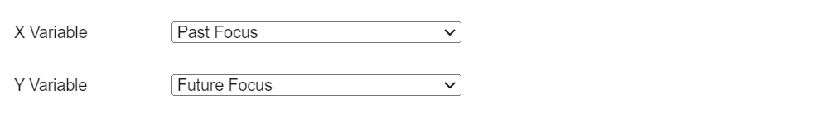

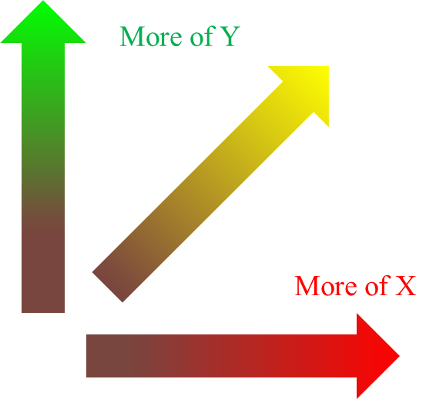A) On the **Clustering 2D** page, you can choose 1 word category for each of the X and Y axis. After choosing your options, a corresponding graph will appear like the example below.

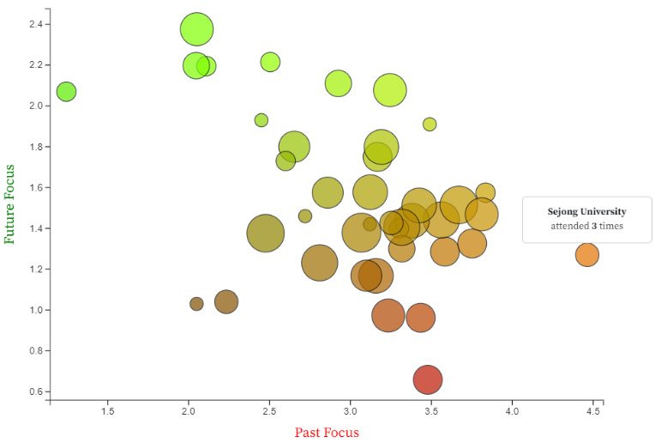

B) There are three main elements in the resulting graph: coloring, circle sizes, and info boxes.

① **Coloring**: The X axis is represented with the color red. The Y axis is represented with the color green. A general frequent usage of both word categories results in a bright yellow, whereas the opposite results in a dark purple. Refer to the color-coding map on the right image.

② **Circle Sizes**: As universities differ in how many times they have attended the competition, the radius of the circles increases in proportion to the attendance rate.

③ **Info Boxes**: When you hover over a circle, you can see the university name and how many times they attended the social pitch competition.

How to use **Clustering 3D**

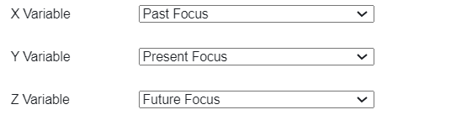

A) On the **Clustering 3D** page, you can choose 1 word category for each of the X, Y, and Z axis. After choosing your options, a corresponding graph will appear like the example below.

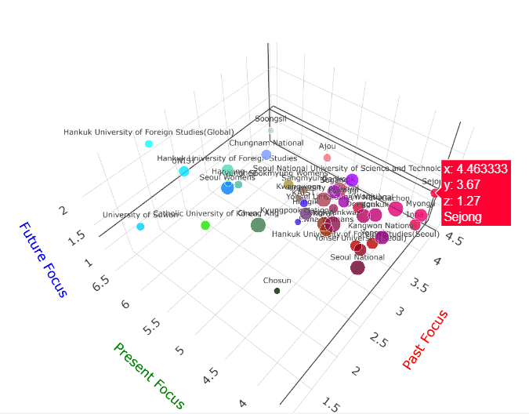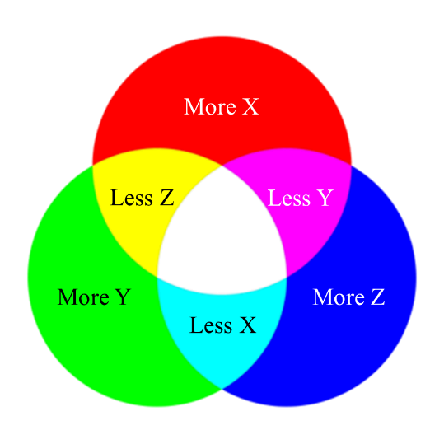

B) There are three main elements in the resulting graph: coloring, circle sizes, and info boxes.

① **Coloring**: The X axis is represented with the color red. The Y axis is represented with the color green. The Z axis is represented with the color blue. A general frequent usage of all word categories results in white, whereas the opposite results in black. Refer to the color-coding map on the right image.

② **Circle Sizes**: As universities differ in how many times they have attended the competition, the radius of the circles increases in proportion to the attendance rate.

③ **Info Boxes**: When you hover over a circle, you can see the university name and the word frequency values for each word category.

* Tip-on-Tip!

You can change the viewpoint, rotate, or zoom in or out using the tool bar on the top right.



How to use **sCatter by Year**

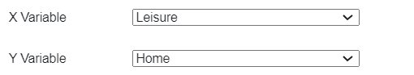

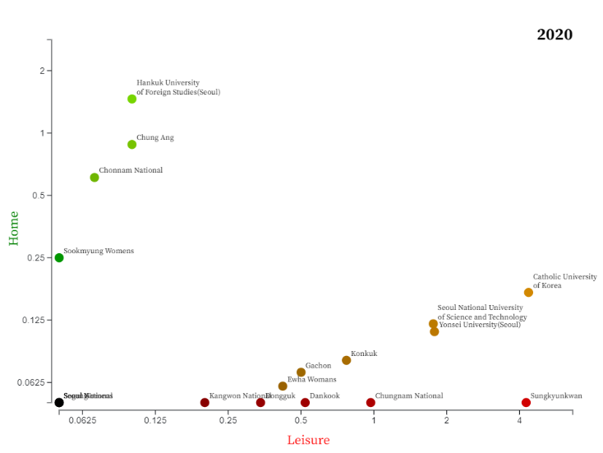A) On the **sCatter by Year** page, you can choose 1 word category for each of the X and Y axis. After choosing your options, a corresponding graph will appear like the example below.

B) There are three main elements in the resulting graph: year, coloring, and labels.

① **Year**: The year is indicated on the top right of the graph.

② **Coloring**: The X axis is represented with the color red. The Y axis is represented with the color green. A general frequent usage of both word categories results in a bright yellow, whereas the opposite results in a dark purple. Refer to the color-coding map on the right image.

③ **Labels**: The name of the corresponding university is indicated next to the circle.

* Tip-on-Tip!

There are two additional interactable elements on this page. The first is the slider. You can move it to change years.



The second is the University Name Finder. If you wish to only track certain universities, you can select/unselect the university checkboxes depending on your scope of interest.



*Be aware that* due to the majority of universities exhibiting extremely low or high values for individual word categories, the X and Y axes of this graph are scaled logarithmically with a base of 2.